

30

MARCH

2022

PROJECT

REPORT



INTERNET PROGRAMMING

**Team members**

Hana Yasser Amgad 18P5007

Omar Mohamed Lotfy 18P5606

Ilaria Refaat Ghobrial 18P3050

Yomna Hussein Mohamed 18P5794

Laila Mohamed Aborizka 18P9654

**Github Link:** <https://github.com/IlariaRefaat/Project-internet-programming>

# PROJECT DESCRIPTION

This website is intended to be a social Q&A as well as a social news and discussion website targeting the students and faculty members of Ain Shams University Faculty of Engineering. All students and members can ask questions and share answers as well as share the faculty's most recent news and interesting discussions. It aims to bring the community together and facilitates sharing information and knowledge. The website keeps track of all information including the date of posts and discussions, content, comments and member info.

1. It contains at least 6 webpages ( Homepage, Login+registration, Blog, About, Profile, Search).
2. Webpages are dynamic
3. Signup, Login, Logout functionalities
4. Admin functionalities to manage posts and members
5. Minimum 25 posts and 10 registered members

# BLOG PAGE DESCRIPTION

Our website contains a Blog page that has multiple topics to help the user find the information or the post related to what he is looking for. Our blog page consists of a navigation bar with the website logo on the left and a horizontal list of the rest of the pages on the right.

Below the navigation bar on the left there is a slogan.

The topics are ordered alphabetically in a vertical list with a photo related to the topic on the left of the topic. The user can click on any topic he is interested in.

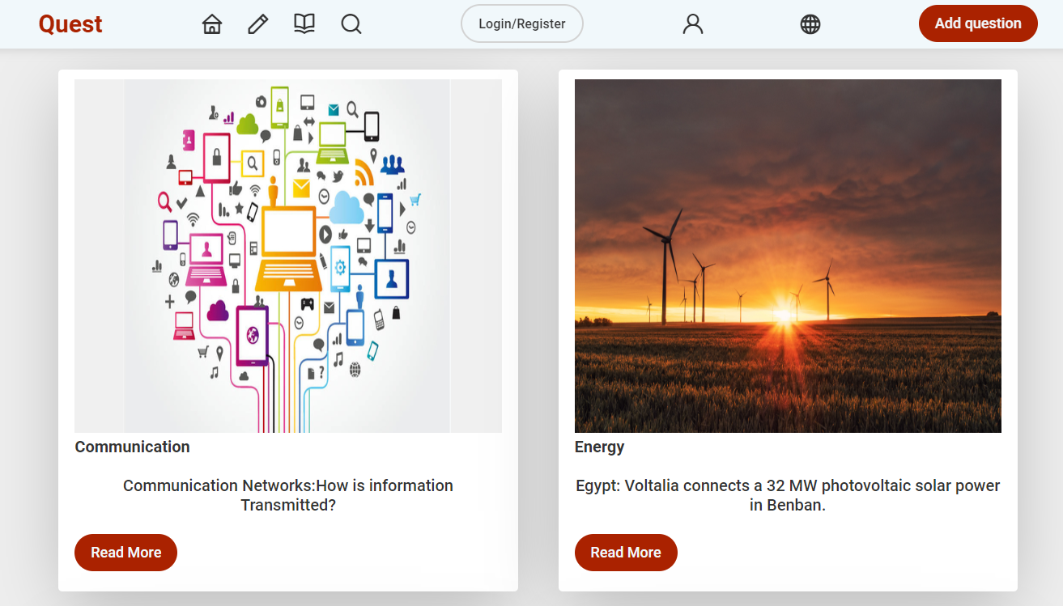

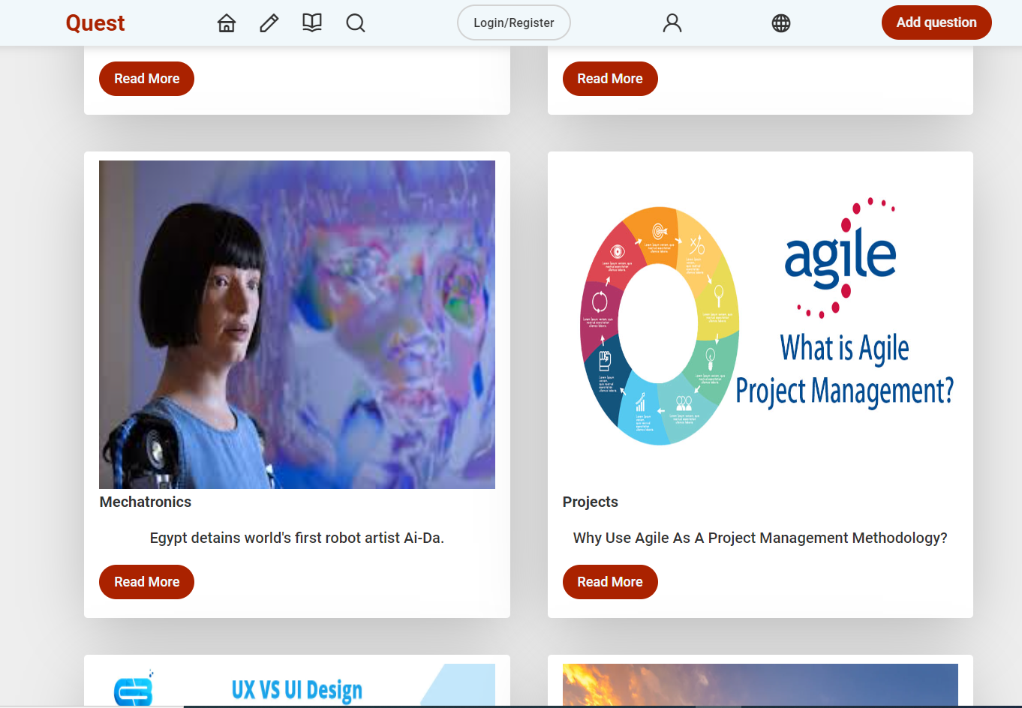



# PROFILE PAGE DESCRIPTION

A web page that provides personal information(Displayed name and photo, Language, Country, Posts) and is accessible to the user only while the displayed name, Photo, Brief and posts are accessible to the public.

1. User can preview the posts he shared.

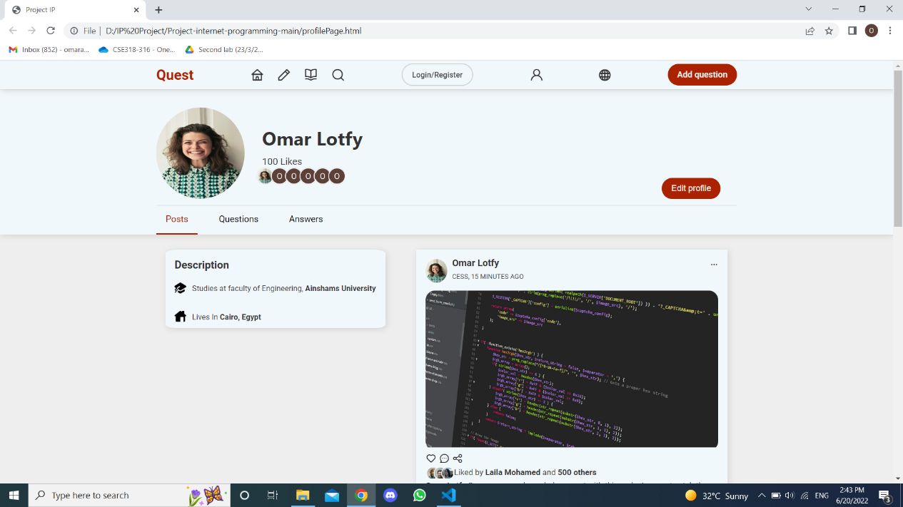

1. User can preview questions without showing the whole posts.

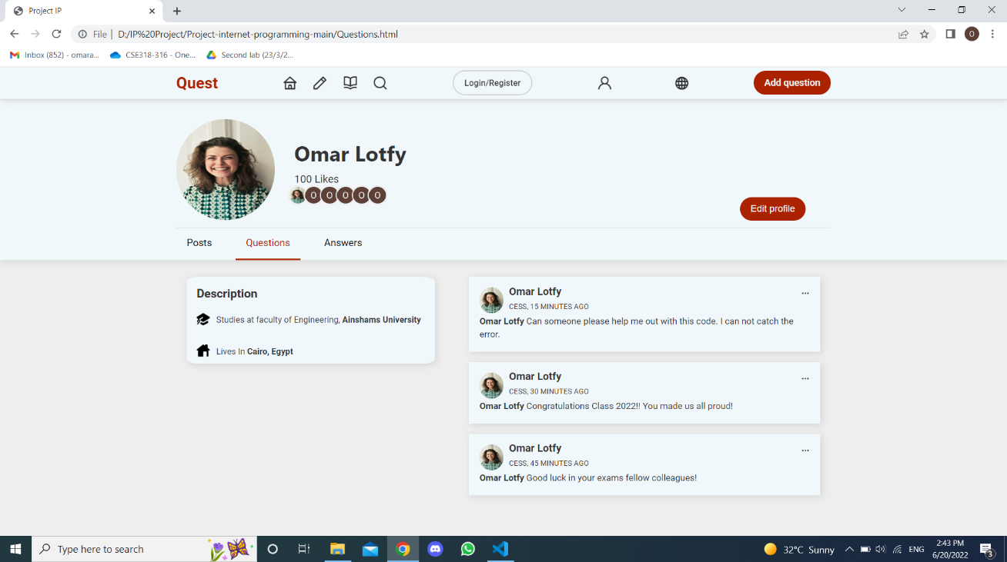

1. User can preview his reponses to other users’ questions.

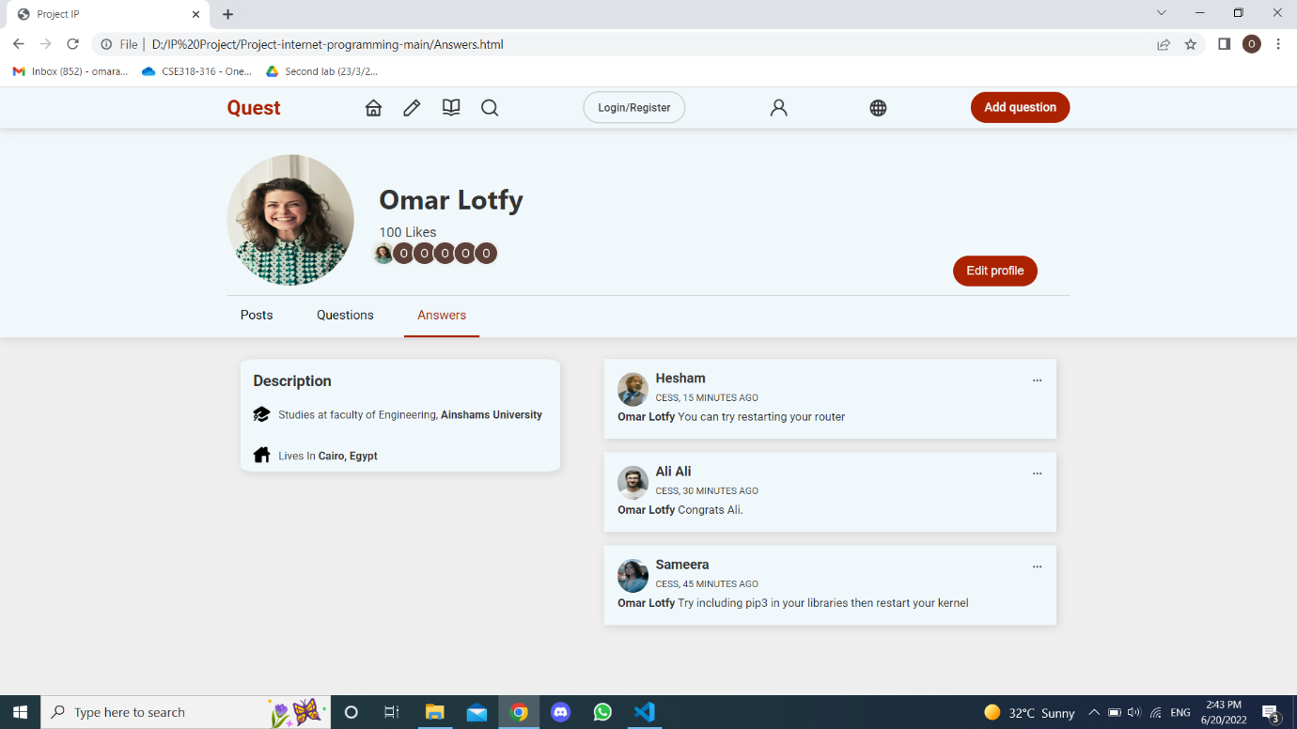

1. User can edit his profile info such as name, password …etc.To change password, user should enter his old password first then create a new one.

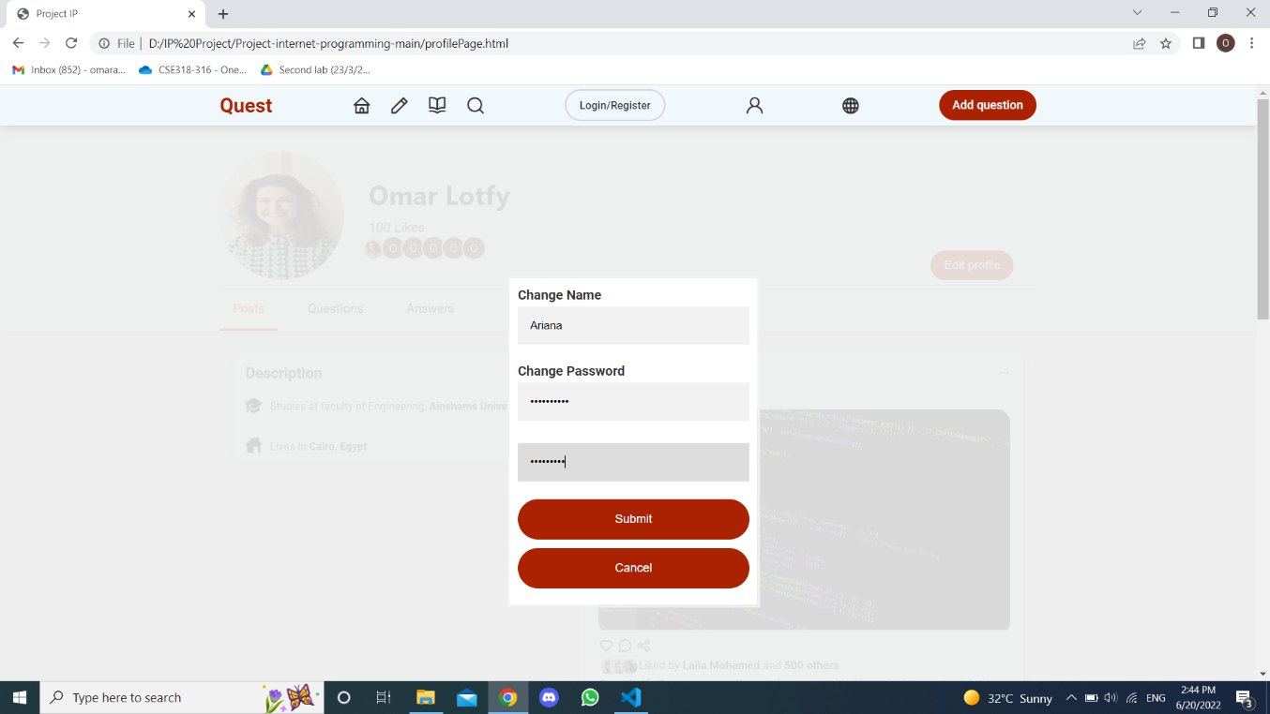

1. Profile page after update (name changed).

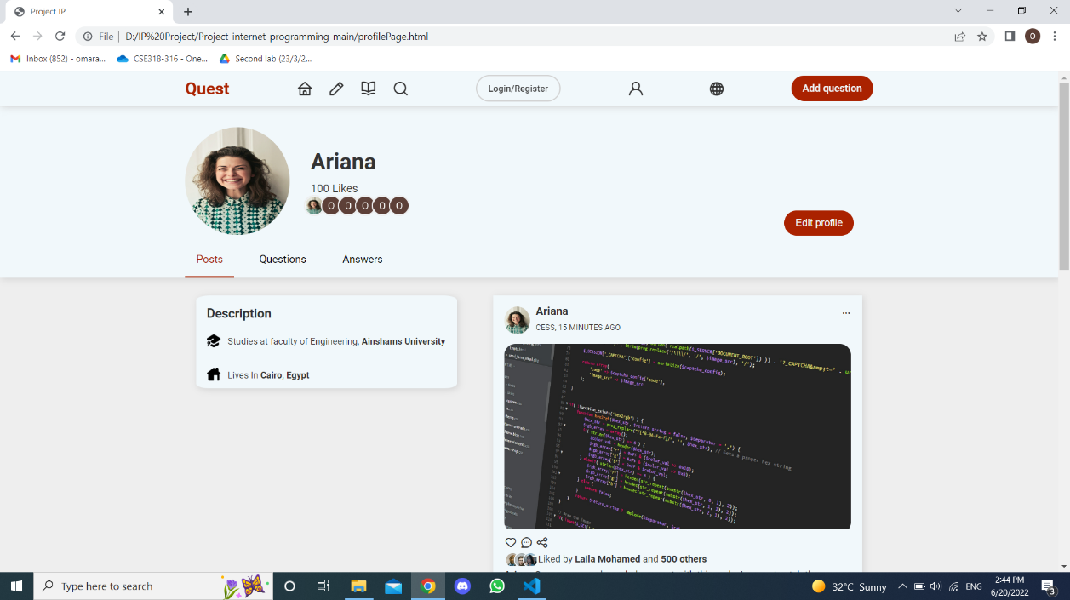

**JS functions description:**

**editProfile():** shows form as a block and sets opacity of background to 0.1

**closeForm():** removes form and sets opacity of background to 1

**Submit():**removes el form, sets opacity to 1, get name from the form and insert it into the profile Page

# HOMEPAGE DESCRIPTION

-A navigation bar with the website logo on the left and a horizontal list of the rest of the pages on the right.

-Icon that refers to login.

-Icon to choose language.

-Most recent discussed topics shown by images, each topic (image) can be accessed by the user.

-Footer contains (user agreement, privacy policy, content policy, all rights reserved, link to the website.

# About PAGE DESCRIPTION

It’s an introductory page to show user history of the website, its main idea, and how many students uses it, a sample of the blogs and also it gives him the ability to join Quest family and to read more about its history.

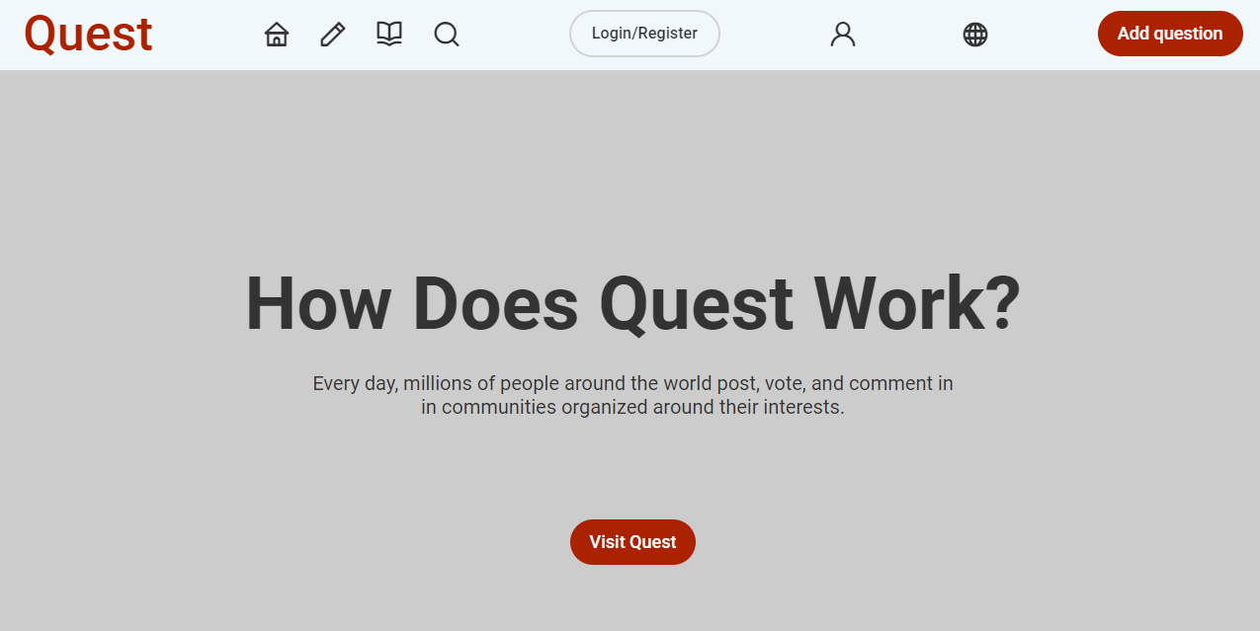

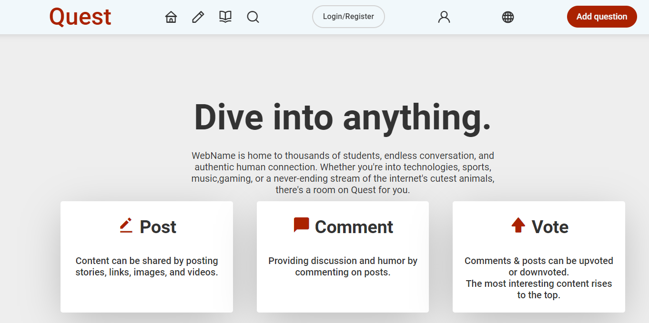

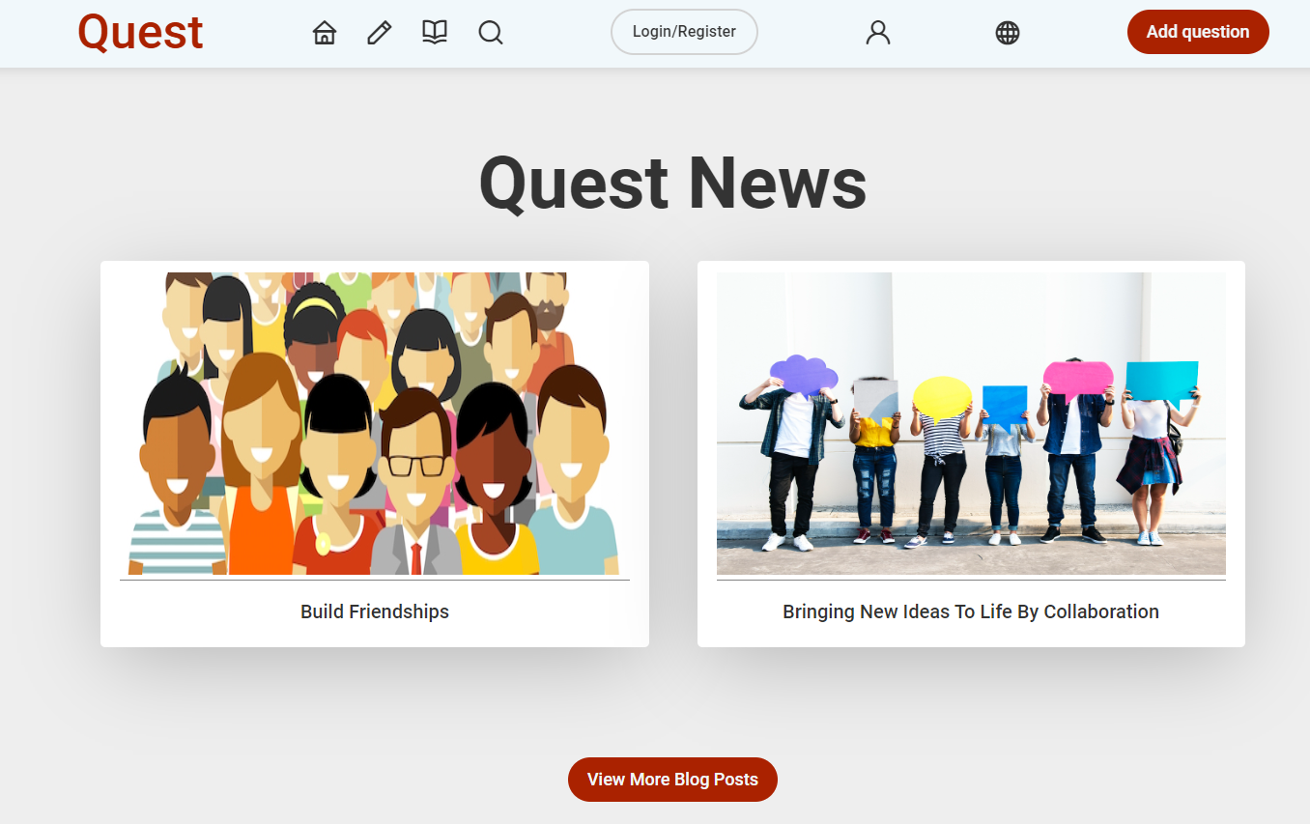

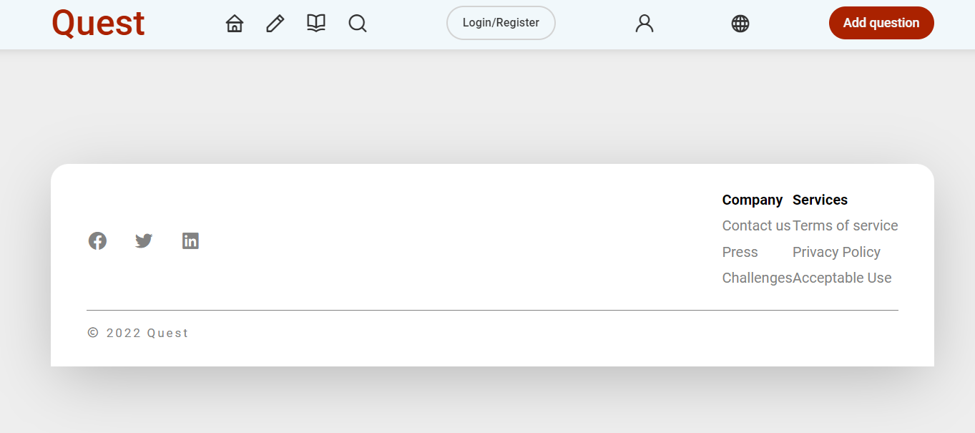

# Search PAGE DESCRIPTION

Search page consists of search engine that helps user to search for other users.

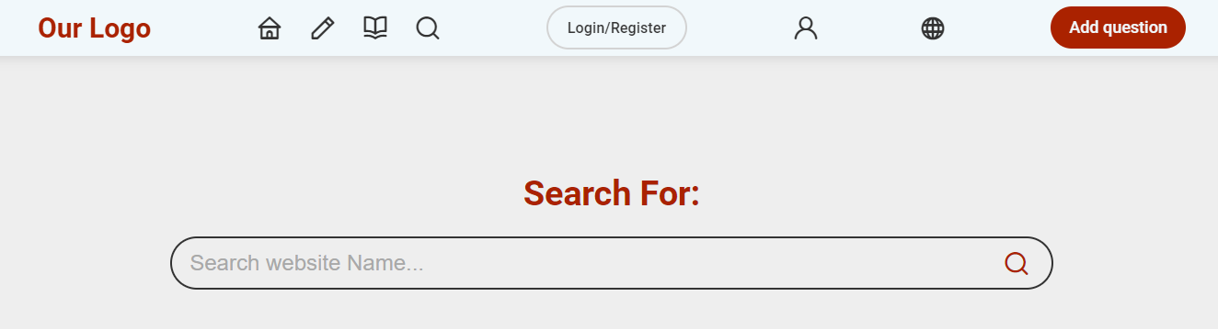

Search engine has the ability to autocomplete.

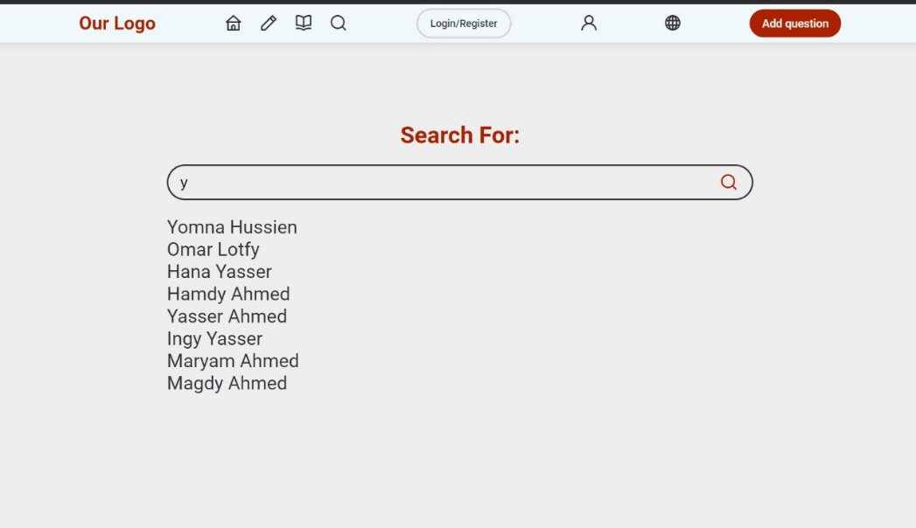

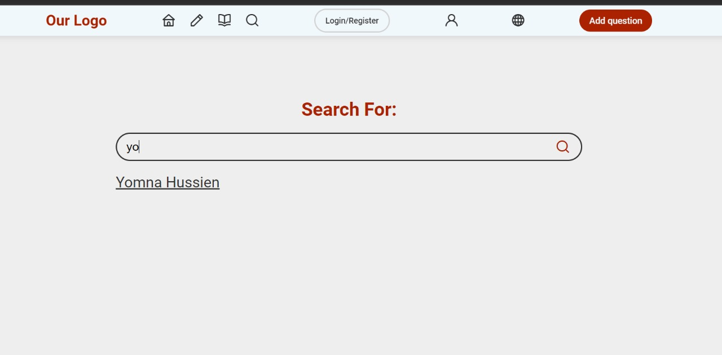

**JS functions description:**

The Search Engine code consists of, on every key press on the keyboard we filter the names that include the search string in the user array that we have. The result is saved on an empty array that is displayed in a form of a list. Then we iterate in that list to give every element an onclick attribute.

**Select ():**If an element is clicked the select function is executed, this function redirect us to the profile page.

# Login PAGE DESCRIPTION

User Login by enterig the correct E-mail and Password, he can also choose to signin using his google or facebook account, If he doesn’t have an accoount he can choose to Sign up for oone.

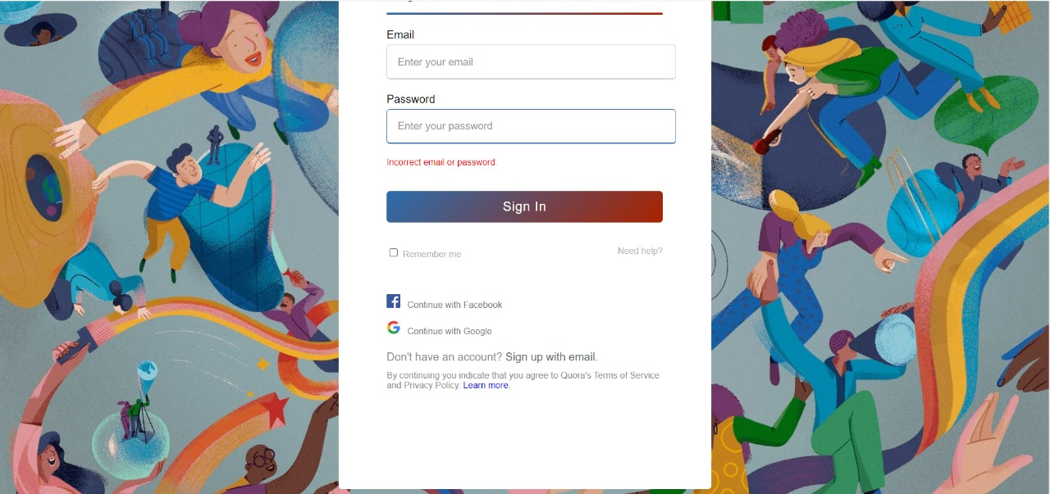

# Register PAGE DESCRIPTION

To register user should enter his personal info (full name, E-mail, phone number). He also should choose his username and password (must contain between 4 and 60 characters) and confirm the password the he chose. System must ensure that the entered email isn’t already in use. User can skip the registration if he already have an account and login directly his account.

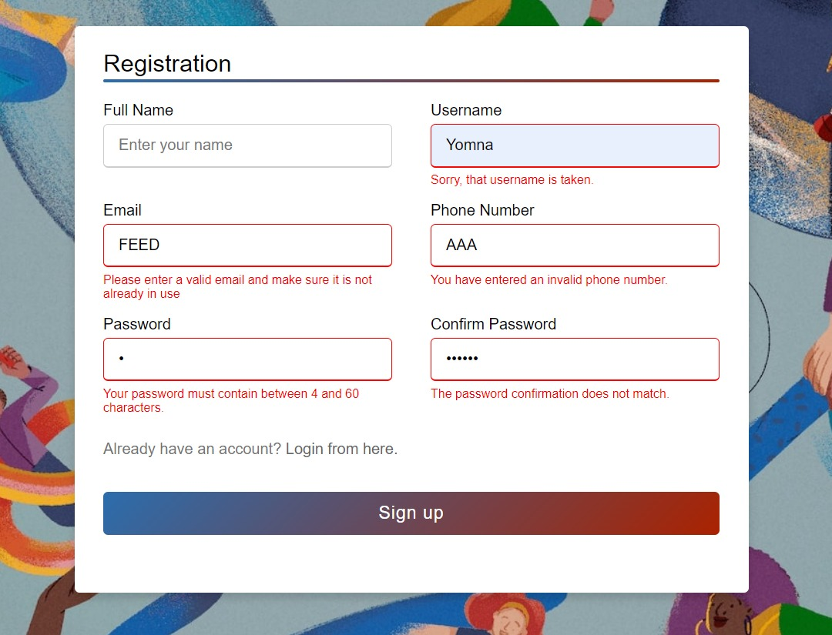

**JS functions description:**

For registration, we have five onBlur functions for the input fields and one onclick functions for the sign-up button, the functions are:

1. **validateUserName():**This function takes the input user name value and check in the user array of objects if already a user with the same user name exists, if that happens, and error will occur saying “the user name is already taken.”
2. **validateEmail():**This function takes the input email value and check if the email is in an invalid form or already found in the user array of objects, if that happens, an error will occur saying “Please enter a valid email and make sure it is not already in use.”
3. **validateNumber():**This function takes the input phone number value and check if the phone number is not equal to 11 digits, if that happens, an error will occur saying “You have entered an invalid phone number.”
4. **validatePassword():**This function takes the input password value and check if the password is does not have between 4 to 60 characters, if that happens, and error will occur saying “Your password must contain between 4 and 60 characters.”
5. **validateConfirmPassword():** This function takes the input confirm password value and check if the confirm password does not match the password, if that happens, an error will occur saying “The password confirmation does not match.”
6. **signUp():** This function activated by clicking on the sign-up button, when it is activated it checks if all fields are filled and no errors happening, if that happen a new user object will be created in the user array of objects with the values the user has entered, and then it will take them to the homepage, the button will not work otherwise.

For login, we have one onclick function for the sign-in button. When the button is clicked, it checks if the input email and password values match any of the values in the user array of objects, if that happens this means the user has entered a correct email and password and it takes them to the homepage, other wise an error will occur saying “Incorrect email or password.”